26.53: The maximum allowed power is when the total current is the maximum allowed value of 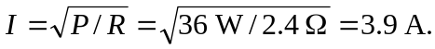Then half the current flows through the parallel resistors and the maximum power is:

